PIZZA SALES SQL QUERIES
A. KPI’s
1. Total Revenue:
SELECT SUM(total_price) AS Total_Revenue FROM pizza_sales;
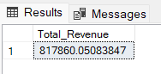
2. Average Order Value
SELECT (SUM(total_price) / COUNT(DISTINCT order_id)) AS Avg_order_Value FROM pizza_sales
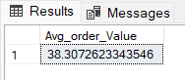
3. Total Pizzas Sold
SELECT SUM(quantity) AS Total_pizza_sold FROM pizza_sales
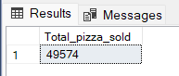
4. Total Orders
SELECT COUNT(DISTINCT order_id) AS Total_Orders FROM pizza_sales
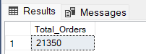
5. Average Pizzas Per Order
SELECT CAST(CAST(SUM(quantity) AS DECIMAL(10,2)) /
CAST(COUNT(DISTINCT order_id) AS DECIMAL(10,2)) AS DECIMAL(10,2))
AS Avg_Pizzas_per_order
FROM pizza_sales
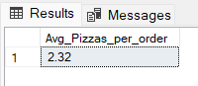

B. Trend Analysis
1. Daily Trend for Orders:
SELECT DATENAME(DW, order_date) AS order_day, COUNT(DISTINCT order_id) AS total_orders
FROM pizza_sales
GROUP BY DATENAME(DW, order_date)
Output:
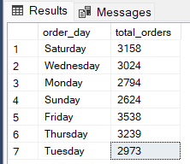

2. Hourly Trend for Orders:

SELECT DATEPART(HOUR, order_time) as order_hours, COUNT(DISTINCT order_id) as total_orders
from pizza_sales
group by DATEPART(HOUR, order_time)
order by DATEPART(HOUR, order_time)

Output
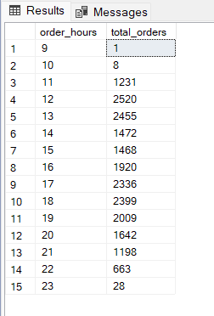

3. Percentage of Sales by Pizza Category:

SELECT pizza_category, CAST(SUM(total_price) AS DECIMAL(10,2)) as total_revenue,
CAST(SUM(total_price) * 100 / (SELECT SUM(total_price) from pizza_sales) AS DECIMAL(10,2)) AS PCT
FROM pizza_sales
GROUP BY pizza_category
Output
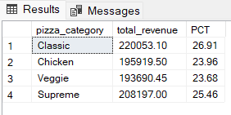

4. Percentage of Sales by Pizza Size:

SELECT pizza_size, CAST(SUM(total_price) AS DECIMAL(10,2)) as total_revenue,
CAST(SUM(total_price) * 100 / (SELECT SUM(total_price) from pizza_sales) AS DECIMAL(10,2)) AS PCT
FROM pizza_sales
GROUP BY pizza_size
ORDER BY pizza_size
Output
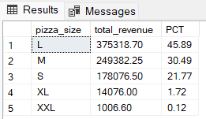

5. Total Pizza’s Sold by Pizza Category:

SELECT pizza_category, SUM(quantity) as Total_Quantity_Sold
FROM pizza_sales
GROUP BY pizza_category
ORDER BY Total_Quantity_Sold DESC
Output
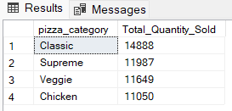
6. Top 5 Best Sellers by Total Pizza’s Sold:

SELECT Top 5 pizza_name, SUM(quantity) AS Total_Pizza_Sold
FROM pizza_sales
GROUP BY pizza_name
ORDER BY Total_Pizza_Sold DESC
Output
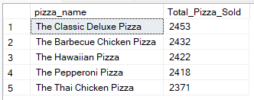
7. Bottom 5 Worst Selling Pizza’s by Total Pizza’s Sold:

SELECT TOP 5 pizza_name, SUM(quantity) AS Total_Pizza_Sold
FROM pizza_sales
GROUP BY pizza_name
ORDER BY Total_Pizza_Sold ASC
Output
